Setting up Stereoscopic Rendering with Unreal nDisplay for
LAVA’s 3D Display Wall (and Samsung Odyssey 3D display)

Jason Leigh
© Laboratory for Advanced Visualization & Applications
Version 05/30/2026

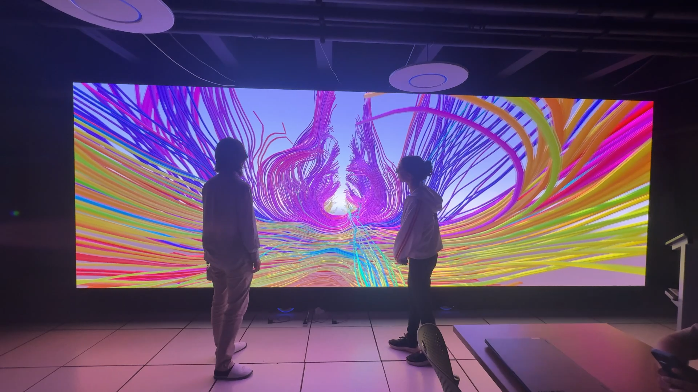
This document provides a step-by-step guide for setting up stereoscopic rendering on LAVA’s 3D display wall using Unreal Engine’s nDisplay, covering both new projects and integrating nDisplay into existing ones. It explains how to configure nDisplay assets, Switchboard launching, and optional low-level setup details.
Before you begin, be aware that nDisplay has not been implemented for the Mac.
There are two ways to start:
- Start with Part A to build a new Unreal 3D Display Wall project.
- Start with Part B if you want to add LAVAʻs nDisplay capability or nDisplay support for the Samsung Odyssey 3D display, to an existing Unreal project.

Then continue with the following parts:
- Part C - Adding LAVA’s nDisplay Asset or nDisplay asset for Samsung Odyssey 3D to Existing Unreal Project
- Part D - Set up the Switchboard and Switchboard Listener to launch nDisplay
- Part F - Tips and Caveats

If you wish to understand how the LAVA nDisplay asset is implemented, go through Part A, especially Part E, D and F.
Part A. Getting Started with nDisplay from Unreal nDisplay Project Template

Unrealʻs nDisplay project template is essentially their simulation template with the nDisplay plugins already installed. To install the nDisplay project, follow these steps:
- Go to Epic Games website and download their hub. From the hub install the latest version of Unreal.
- Having installed Unreal, launch it by clicking on the Launch Unreal Engine button
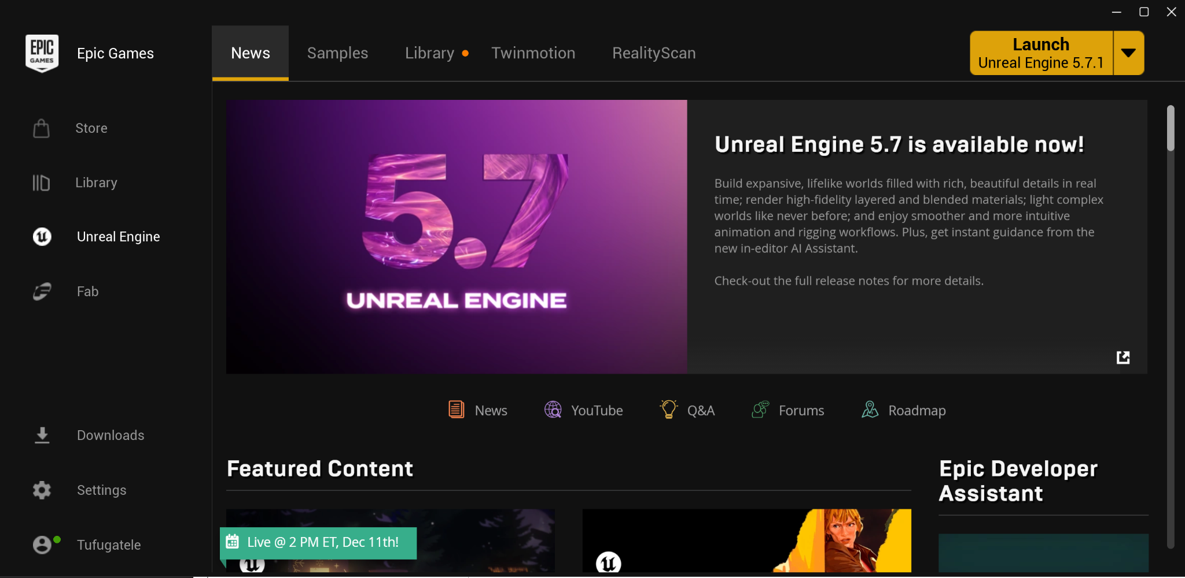
- Create an nDisplay template project as follows: Click on New Project. Then click on Film/Video & Live Events. Choose the nDisplay template project and enter a suitable project name.
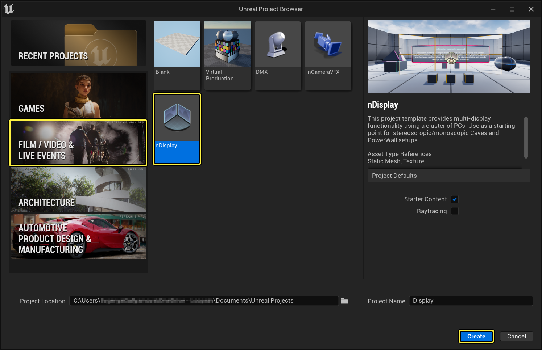
- Once the project is launched, look for the NDC_Basic actor in the Outline tab of your project. If you intend to go onto Part C, you can delete the NDC_Basic actor. If you plan to go on to Part E do not delete NDC_Basic actor.

Part B. Adding nDisplay and Switchboard Plugins to an Existing Unreal Project

- From your Unreal editor, go to the Edit menu and click Plugins.
- Search for the nDisplay plugin and enable it. You may have noticed that there is an nDisplay Launch plugin too. Do not enable that. Itʻs something you can explore later.
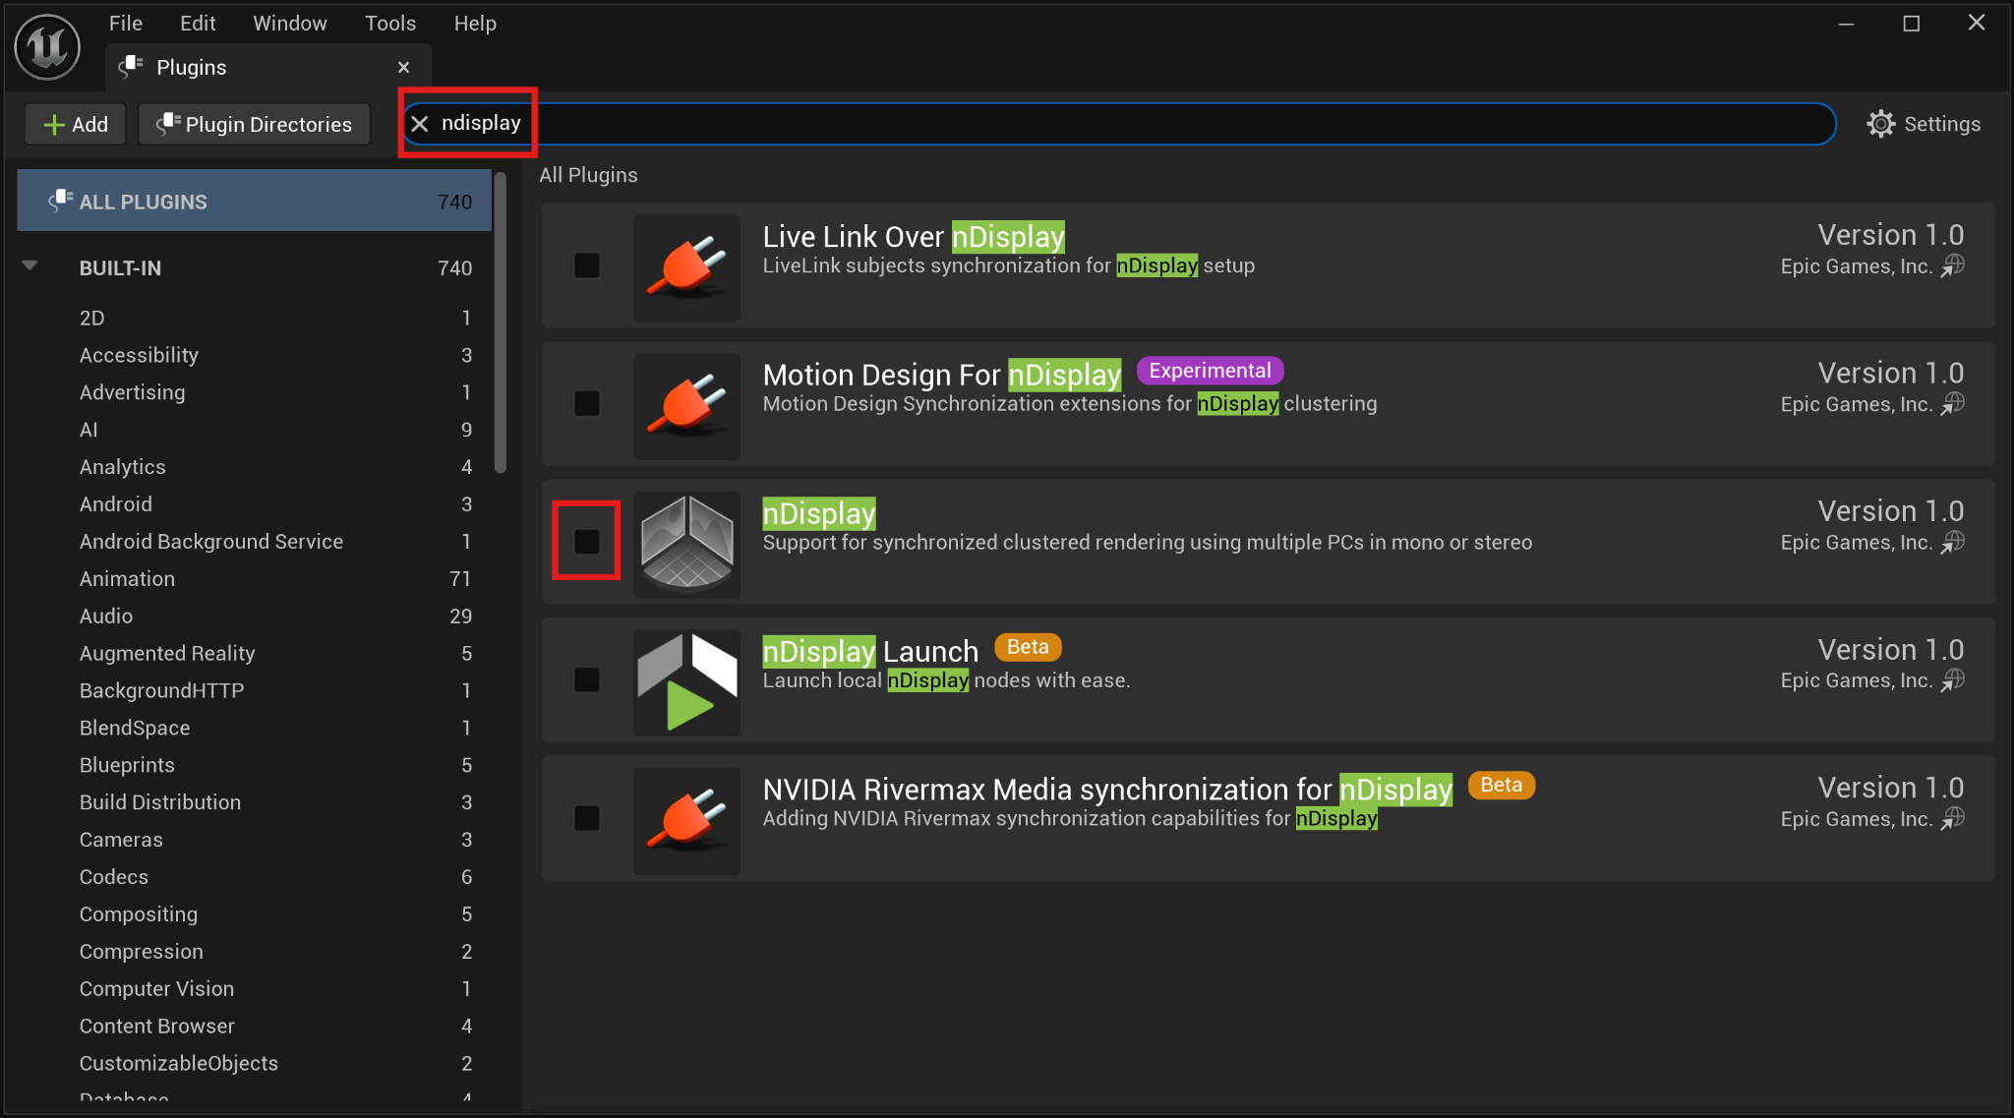
- Now search for the Switchboard plugin and enable that too.
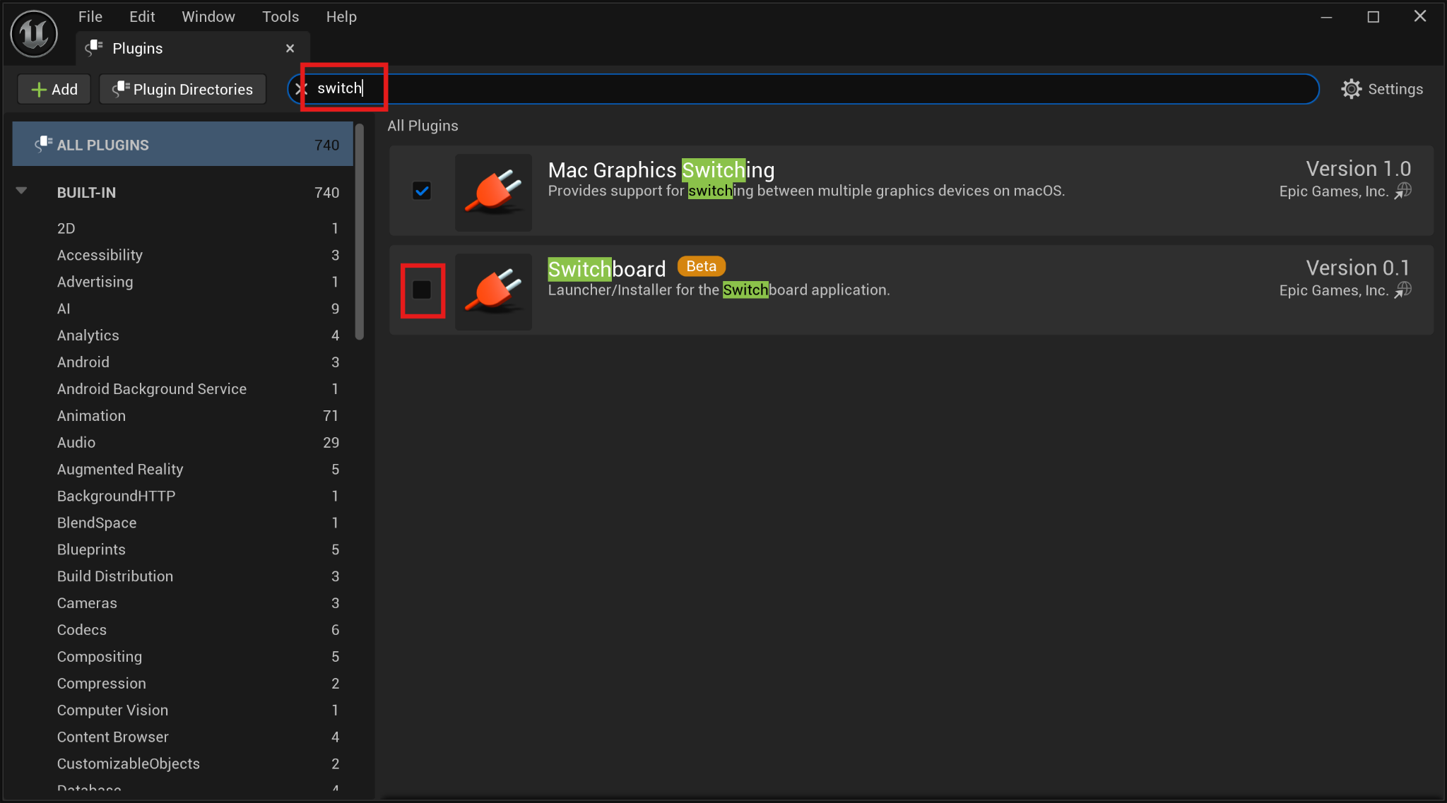
- By now, you will likely also notice a prompt at the bottom of the plugin window asking you to restart Unreal. Go ahead and click on Restart.
- You should see this at the top of your Unreal editor. Part D will explain how to use those buttons.
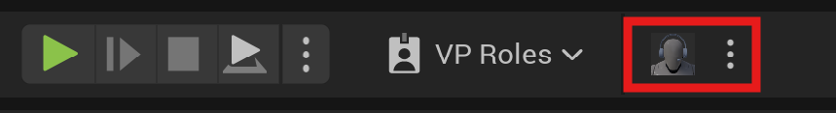

Marked in RED are the controls for the Switchboard- which will be explained in Part D.
Part C. Adding nDisplay Support and LAVA nDisplay Asset to Existing Unreal Project

- Download the NDC_Basic_LAVA.uasset, NDC_Sim_LAVA.uasset, and NDC_Basic_SamAcer.uasset files. (https://github.com/doctorspiffy/Unreal-nDisplay-3D-Wall) Copy and paste them into the Content folder of your UnReal project. Youʻll see them appear in your Unreal editorʻs content browser tab.
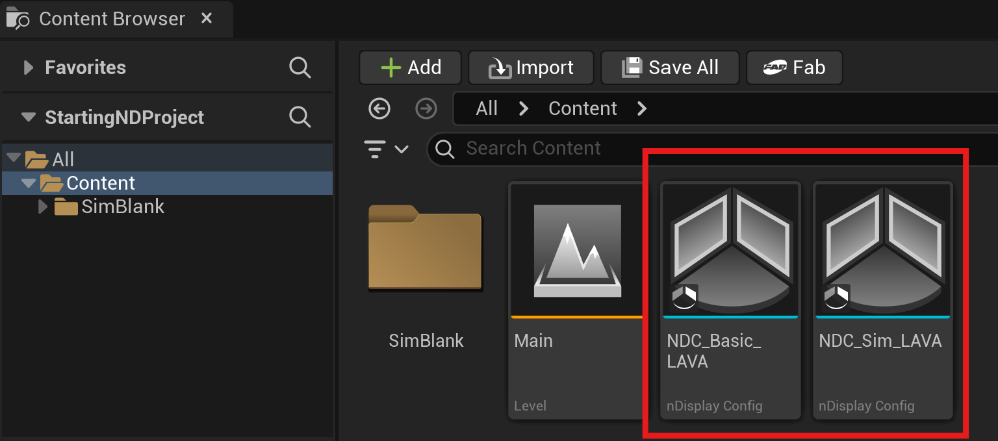
- Drag either NDC_Basic_LAVA, NDC_Sim_LAVA, NDC_Basic_SamAcer asset into the Unreal editorʻs scene window to turn it into an actor, and then position and orient the resulting nDisplay preview window as appropriate. Note the following difference between NDC_Basic_LAVA and NDC_Sim_LAVA:
- The NDC_Basic_LAVA asset contains the nDisplay configuration to drive LAVAʻs display wall which requires you to render two side-by-side stereo pairs of 4800x1620 each- making a total resolution of 9600x1620. Such resolution will require substantial graphics memory and may choke a development laptop.
- The NDC_Sim_LAVA asset contains an nDisplay configuration of a scaled down display wall that you can use to make development possible on computers with lesser graphics capability.
- The NDC_Basic_SamAcer asset contains an nDisplay configuration for the Samsung Odyssey 3D display. If you have the Pro version of the Acer SpatialLabs display, this asset will likely also work for that display as well.

NOTE: If you intend to support multiple display configurations under one project, make sure to add all the relevant ones in the scene window. If you donʻt do that Unreal will not render the stereo pairs correctly in the missing configuration.
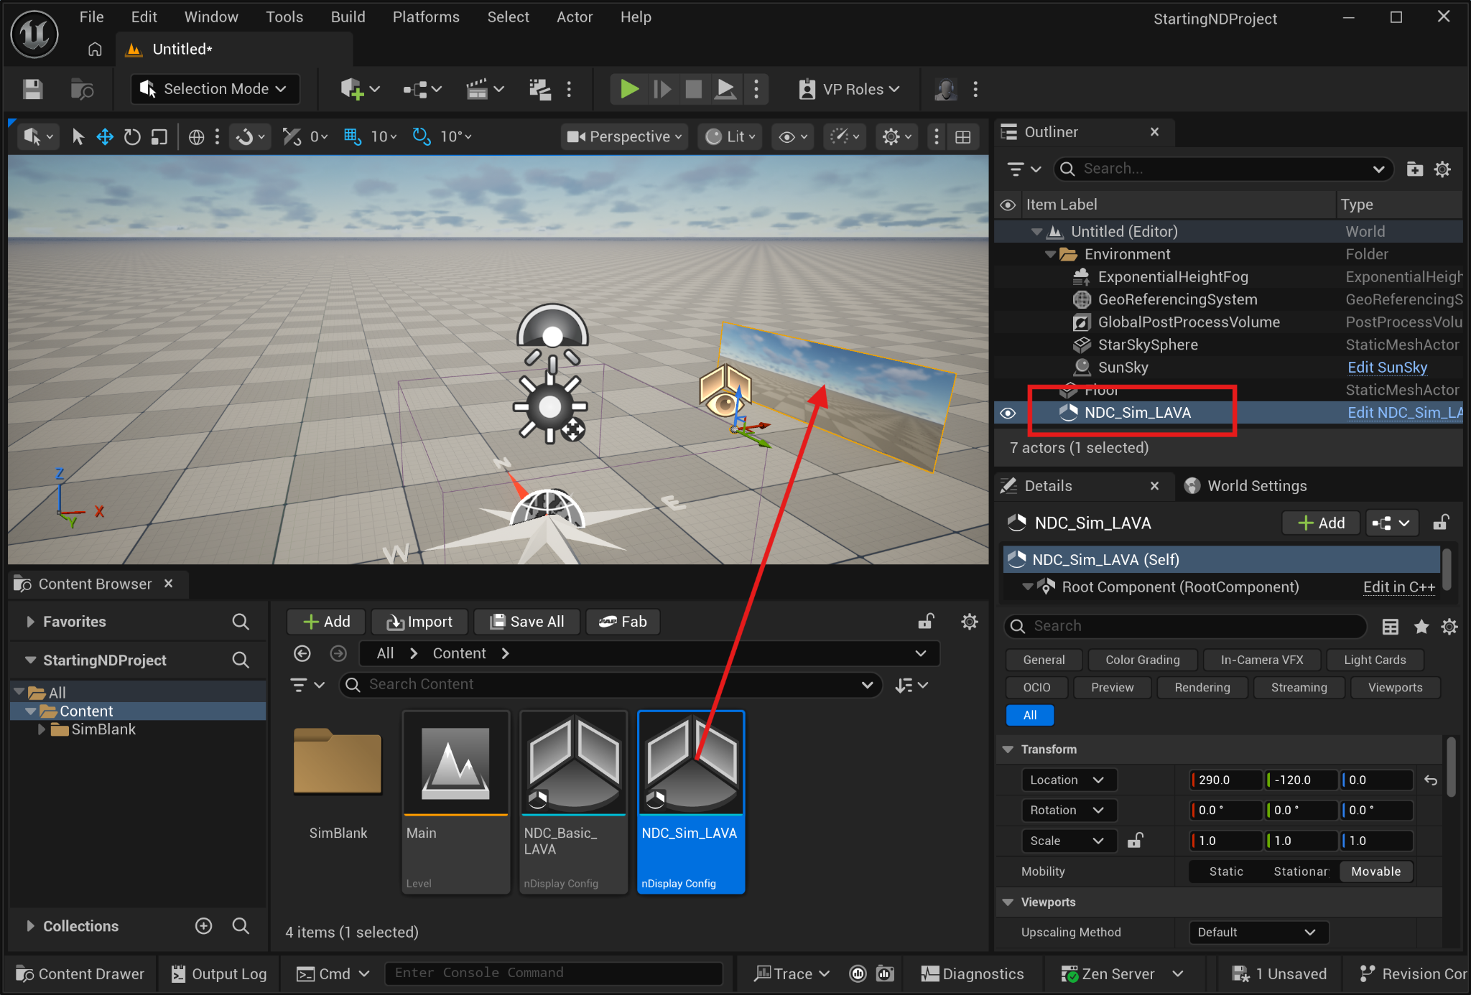
- Now go to the Unreal Editorʻs File menu and click Save All.

Part D. Set up the Switchboard and Switchboard Listener to launch nDisplay

If you attempt to run your program by clicking on Play in the Unreal Editor, it will run the program but not by using nDisplay. To run via nDisplay, you need to use the Switchboard.

The switchboard controls the devices (computers) that drive the displays in your VR-room set up (whether itʻs a single display wall or a CAVE). Switchboard does this by communicating with Switchboard Listeners, potentially running on separate computers, to launch copies of your project. For a single display wall, both the Switchboard and Switchboard Listener will reside on the same computer. For more information on nDisplay visit: https://dev.epicgames.com/documentation/en-us/unreal-engine/ndisplay-overview-for-unreal-engine

The following are instructions for setting up Switchboard and the Listener:

- In the Unreal editor, go to the Toolbar, click the 3 dots next to Switchboard and choose Launch Switchboard Listener.
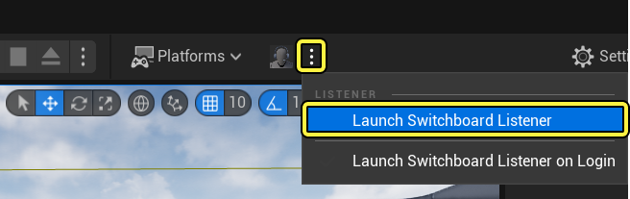
- Switchboard Listener launches and may immediately minimize itself. You may also be asked to provide a password. If you are not asked for the password then your organization may already have set one, so ask your administrator. Actually, if you look at the Settings menu in the listener there is an option for you to change the password if necessary. Later this password will be used to authorize the connection between the Switchboard and the Switchboard Listener.
- Anyway, continuing- once the switchboard listener is open, minimize it (donʻt close it).
- In the Unreal editor Toolbar, click the Switchboard button to launch the Switchboard application on your computer.
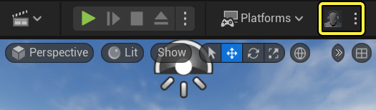
When launching Switchboard for the first time, a command prompt window may appear, installing required dependencies before the Switchboard window opens. Allow the installation to proceed.
- When the switchboard opens, the Add new Switchboard Configuration window will likely appear. A switchboard configuration is needed for each Unreal project that will need to use nDisplay. If this window does not appear go to the Switchboardʻs Configs menu and click New Config.
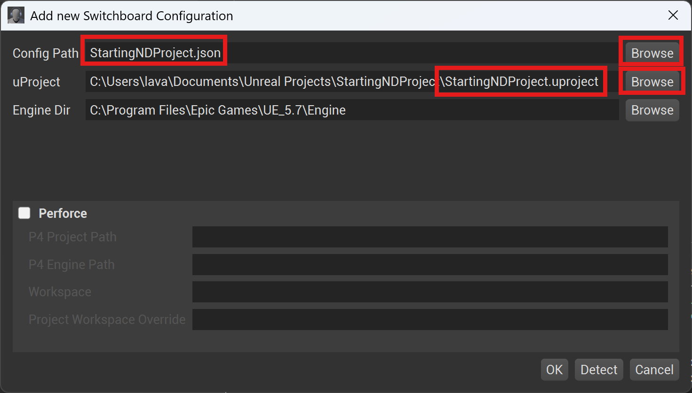
- Give a name to Config Path field- by clicking on the Browse button next to the field.
- Then in the uProject field, browse to your projectʻs .uproject file.
- Then click OK to proceed.
- In Switchboard, click Add Device in the top left and choose nDisplay to open the Add nDisplay Device window.
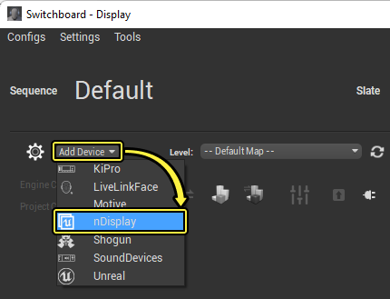
- Browse for and select the nDisplay .uasset configuration file in your project (either NDC_Basic_LAVA.uasset, NDC_Sim_LAVA.uasset, or NDC_Basic_SamAcer.uasset), and click OK. If you are doing this for the first time, I recommend using NDC_Sim_LAVA. NDC_Basic_LAVA is the configuration for the actual display wall. NDC_Sim_LAVA is intended as a lower resolution simulator that can run on weaker laptops/PCs. Later you will want to repeat the above steps in Part D to create a separate device configuration for NDC_Basic_LAVA or NDC_Basic_SamAcer.
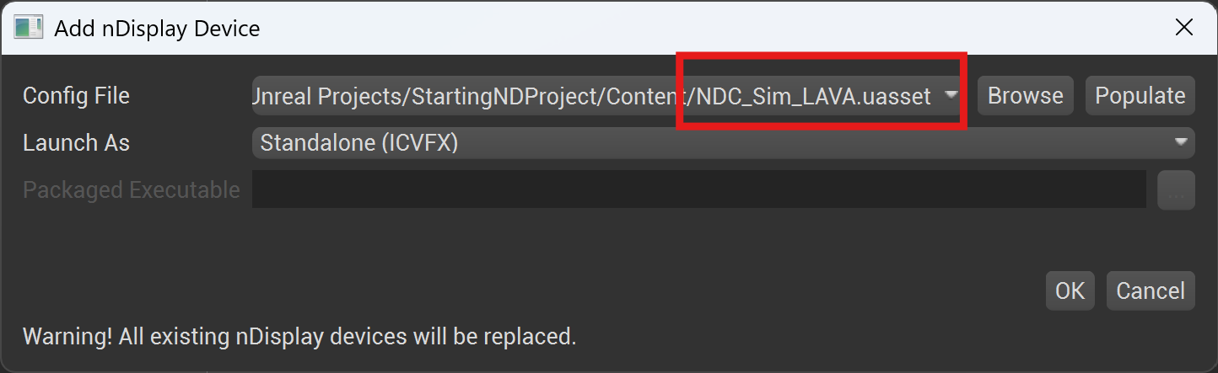
- Continuing- now click on the Settings menu in the Switchboard and make sure the Project Settings sub-panel, the nDisplay Settings sub-panel, and the Node_0 sub-panel contain the correct information. Below are examples of what you might see. Notice the paths show the location of your project file and the nDisplay uasset.
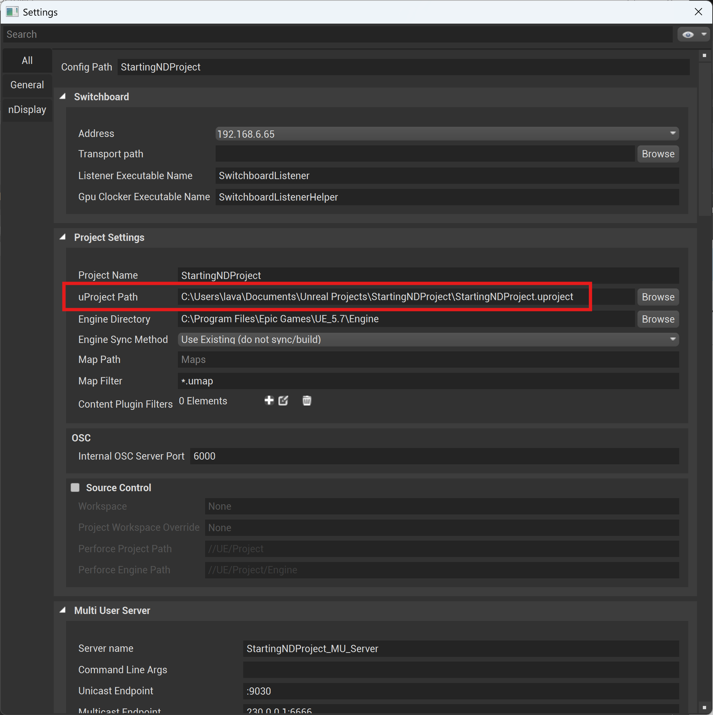
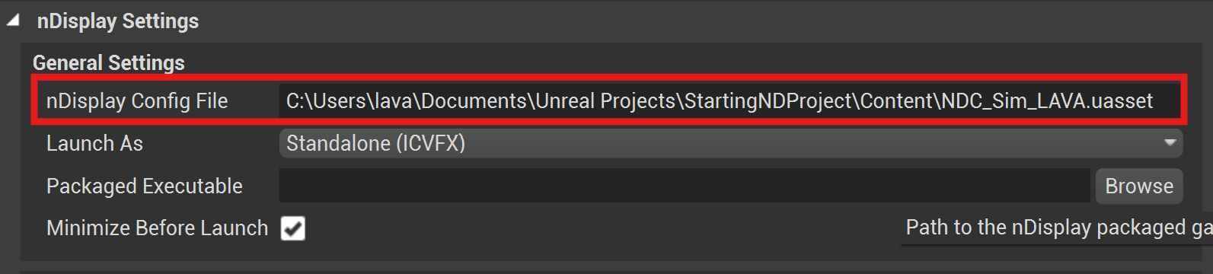
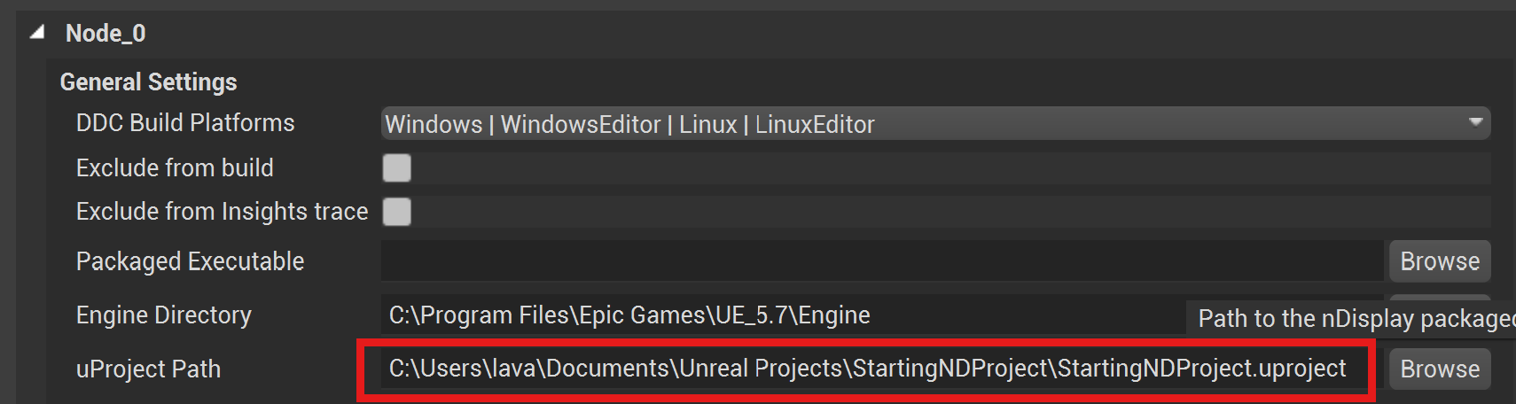

- Close the Settings window.
- In the Switchboard window, make sure Level is set to the correct “game” level of your app.
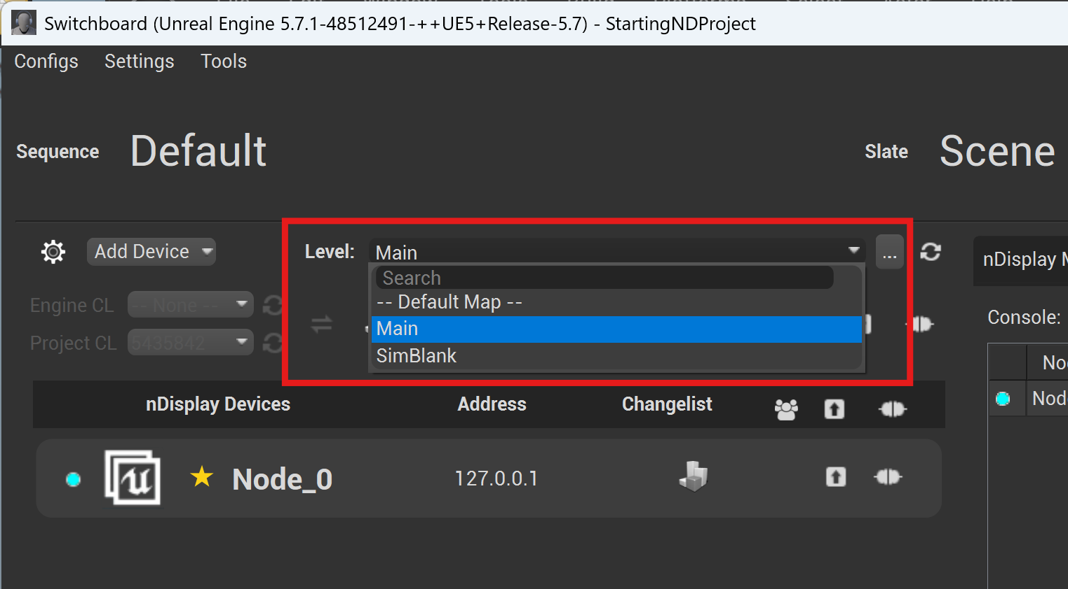
- Click the Connect to listener button to connect to the Switchboard Listener. You may be asked to provide the password that you chose earlier.
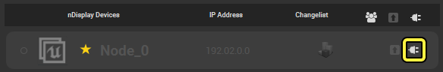
- Start the nDisplay instance. This will immediately minimize all windows and launch the nDisplay instance showing the scene. Note: it will take some time for the scene to finally appear, so be patient- especially on slower computers or for large projects.
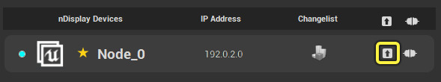
- Once launched, you should be able to interact with your program. For example, if you started with the nDisplay template project you should be able to use First-Person-Shooter controls (WASD + mouse) to move about the environment.
- Press the ESC key to exit the application.

Important Final notes:

- If you are supporting multiple display configurations, you need to have an nDisplay configuration for each one of them.
- When you use your Switchboard again later, you can quickly bring up the appropriate configuration for your project by clicking on the Config menu and selecting the previously created configuration. Donʻt just assume that the configuration you see loaded by default is the correct one, as it may be the configuration for someone elseʻs project since your display wall is used by multiple people for multiple projects.
- When using the Samsung Odyssey 3D display, once the Unreal app has launched from the Switchboard, click on the Unreal app and press F11 to force a window maximize (even though it already looks maximized). Then your Samsung should properly detect a maximized window and enable stereo.

Part E. Set up nDisplay Actor from Scratch for Stereoscopic Rendering on LAVA’s Display Wall

This part of the tutorial is optional to most users. It explains how to build LAVA’s nDisplay actor from Part C from scratch. However you may also want to read this if you intend to modify the configuration in some way.

Fundamentally what LAVAʻs nDisplay asset does is, for each eye of your stereo image, assign each view point to a viewport, and the viewports map to an nDisplay Screen. Whereas the viewport specifies the pixel resolution of the wall, the nDisplay screen specifies the physical dimensions of the wall.
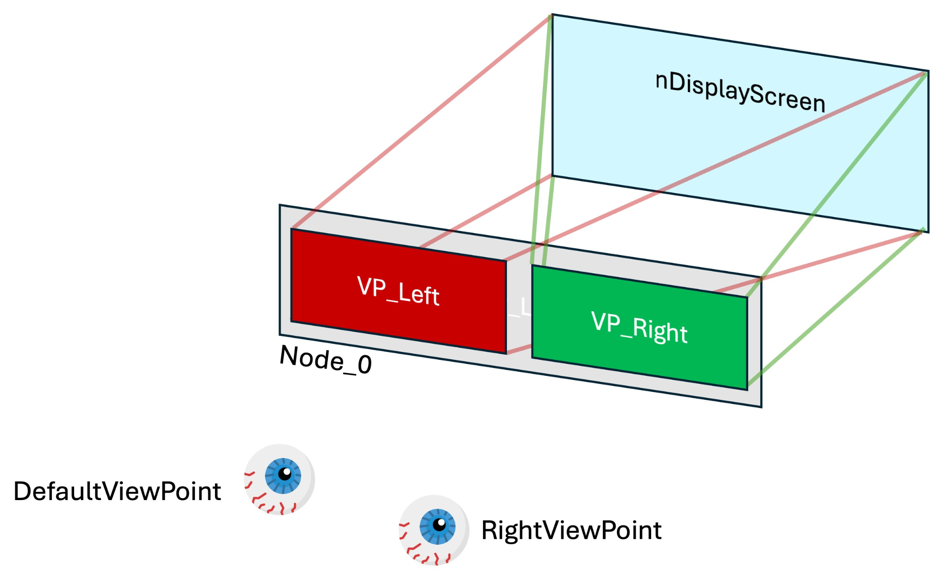
A view point is essentially the location of the user relative to the display wall.
A view port is the region into which the graphics will be rendered.
The nDisplay screen is the virtual representation of the physical display wall.

The steps needed to do this are as follows:
- Continuing from Part A, edit your nDisplay actor (NDC_Basic) in the Outliner tab of your nDisplay project.
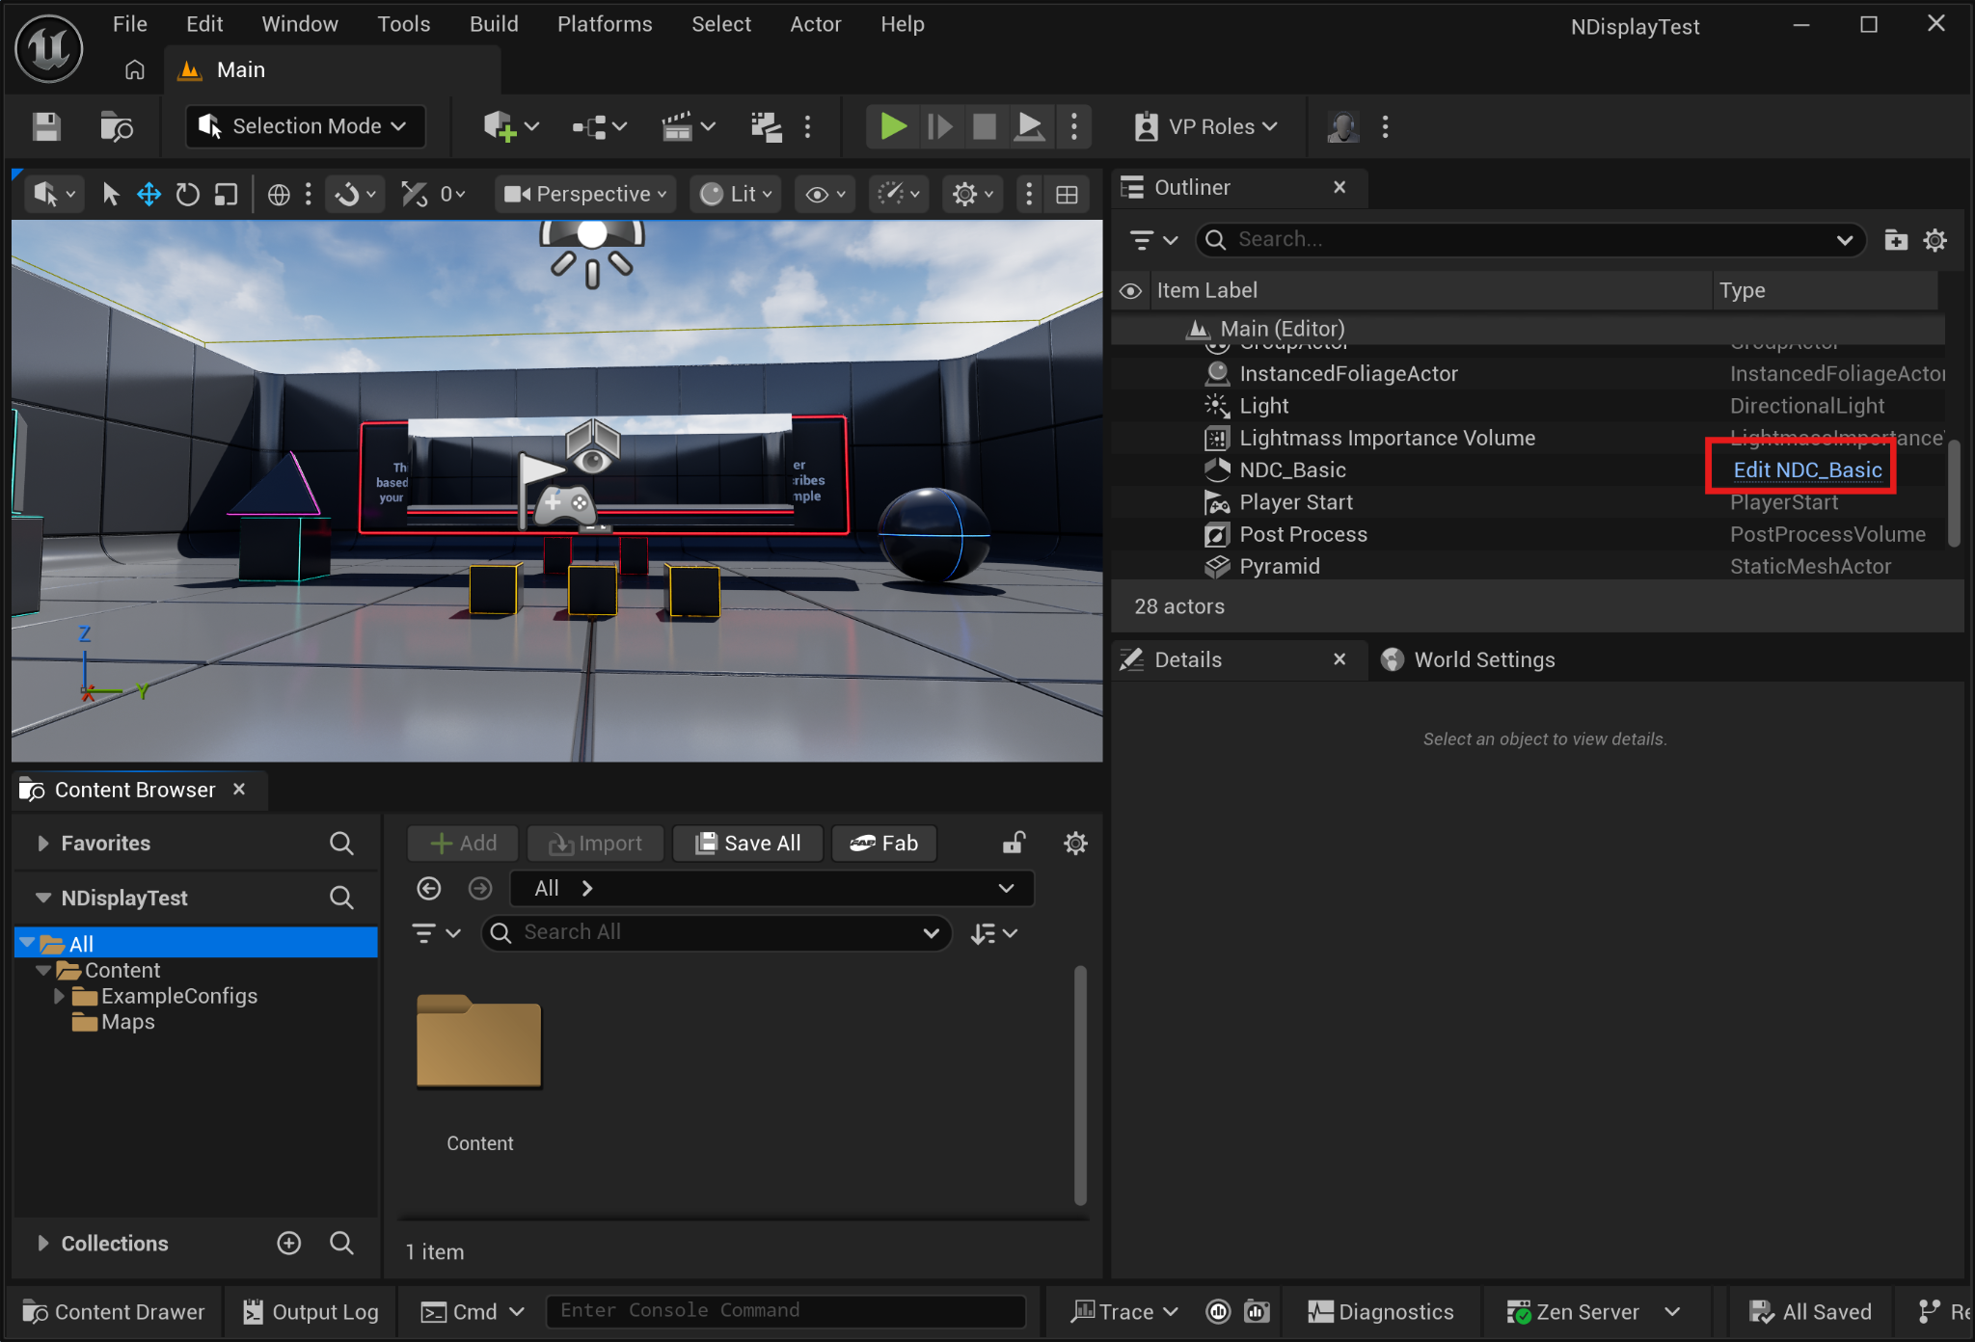
- This is what the NDC_Basic’s editor interface window look like:
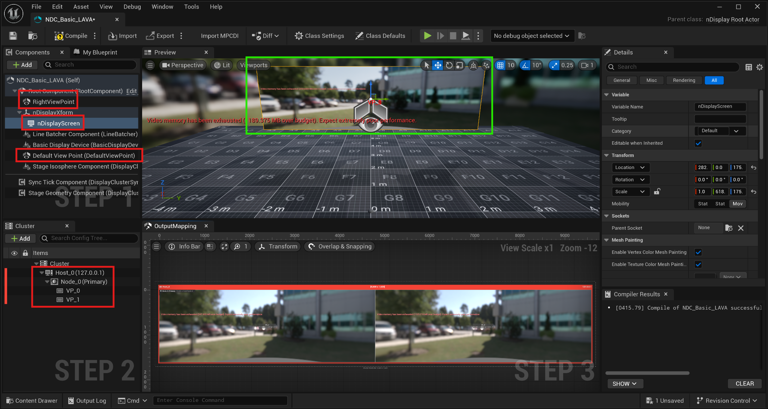
Marked in RED on the left are the nodes we will be modifying. The top left tab shows the components of the nDisplay actor. The bottom left tab shows the nDisplay cluster settings. The Preview window in the center-top shows in green the nDisplay screen. The bottom Output Mapping window shows how the viewports map to Node_0ʻs frame buffer.
- We’re going to use the Default Viewpoint for the left eye. So click on Default Viewpoint in the Components panel and in the details panel on the right look for Stereo and set the Stereo Offset to Left Eye.
- Make sure for the viewpoint, the camera setting → source camera is set to Active Engine Camera, and also make sure Follow Camera is checked.
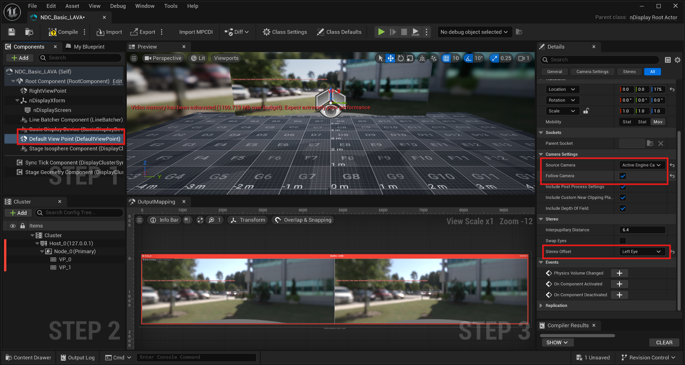
- We’ll create a new viewpoint (and call it RightViewPoint) for the right eye, by duplicating the Default Viewpoint and setting stereo to right eye. To duplicate the Default Viewpoint, right click on it to bring up a menu and select Duplicate.
- Set the Default ViewPoint and RightViewPoint’s location to 0, 0, 175 (5’7” ~ 175cm). This also assumes the adult is standing at the center of their physical world.
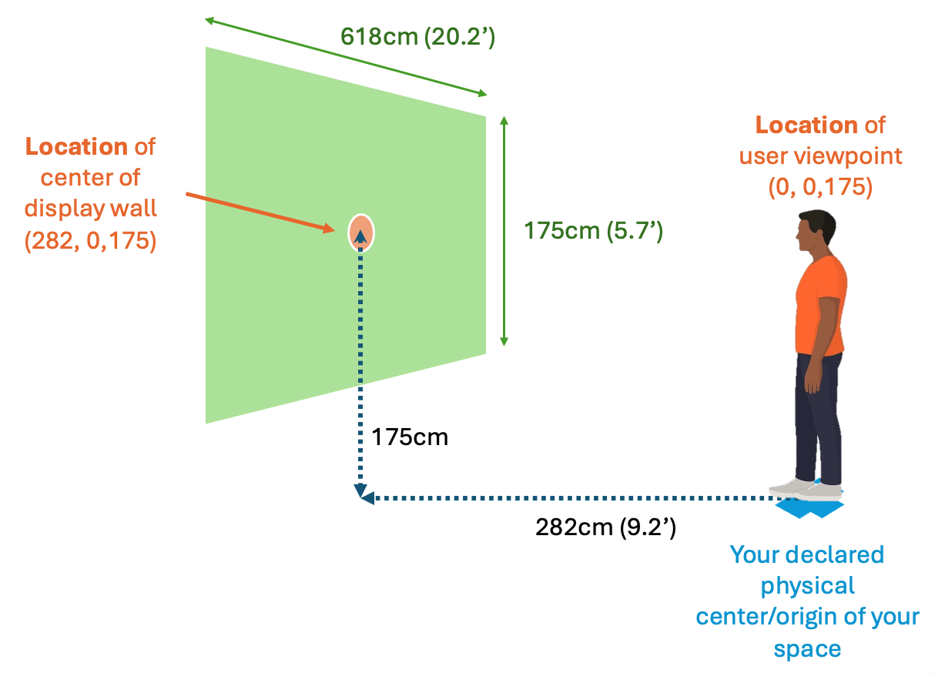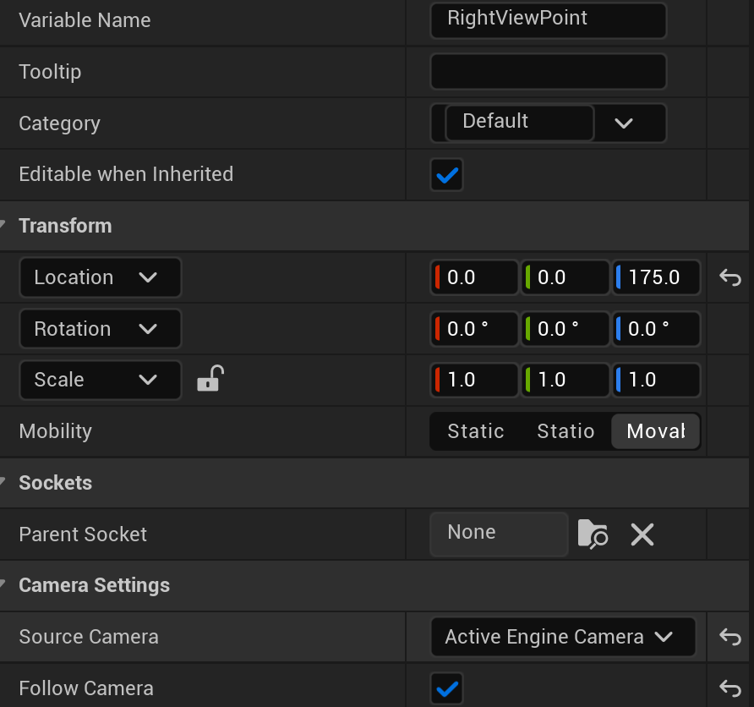

- Rename VP_0 to VP_Left by right clicking on VP_0 and selecting Rename.
- Create a second viewport by duplicating VP_Left (call it VP_Right).
- Set nDisplayScreenʻs Transform and Screen size to the values shown below:
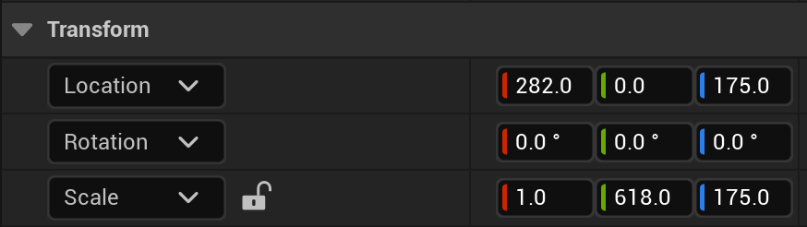
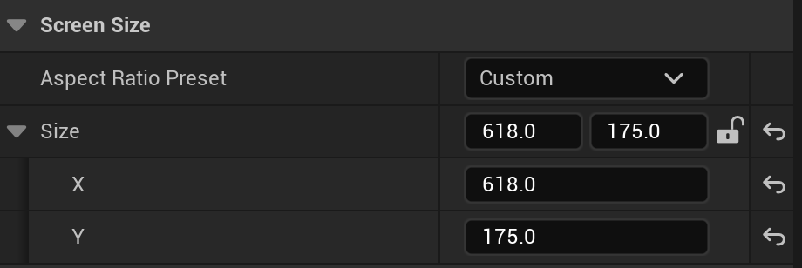
- This sets the physical screen size to 618cm x 175cm (which is 20.2’ x 5.7’). The screen is also set to 282cm (9.2’) in front of the viewer.
- For Node_0 rendering size, set it to the full stereo width (in pixels) of the display wall and the individual viewports (VP_Left and VP_Right) to half the size:
- For Node_0ʻs Full Screen setting, make sure it is NOT checked
- For Node_0 Size is 9600x1620
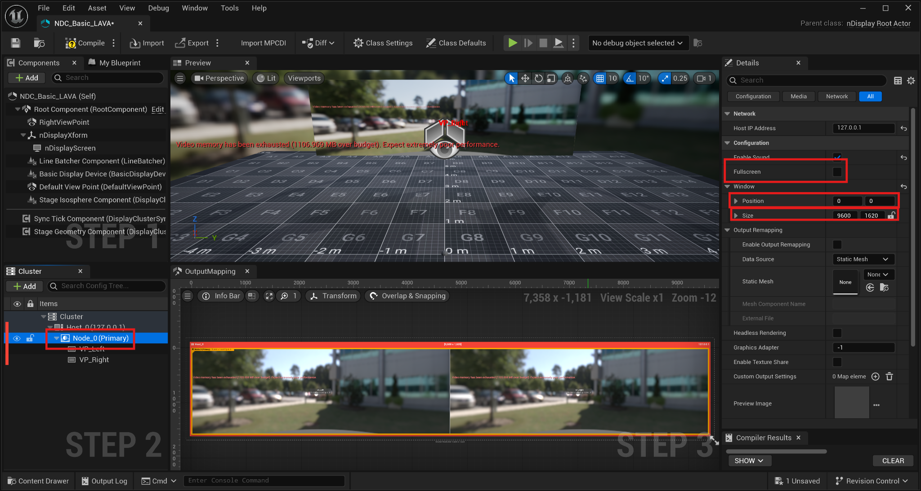
- For VP_Left Size is 4800 x 1620
- For VP_Right Size is 4800x1620
- For VP_Right Position set it to 4800x0

- In VP_Left set the Configuration/View Point to DefaultViewPoint
- Set its Projection Policy/Type to Simple and Projection Policy/Screen to nDisplayScreen
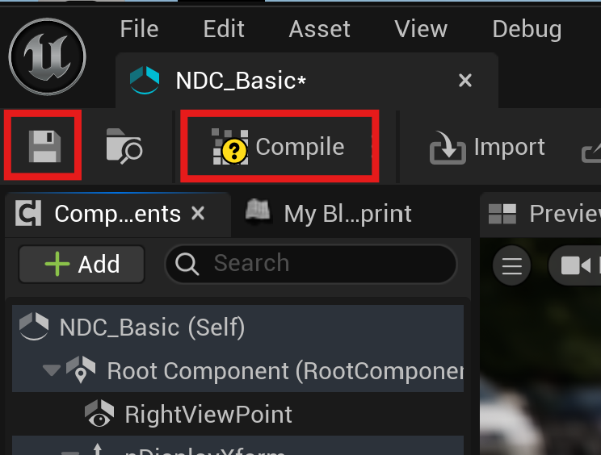
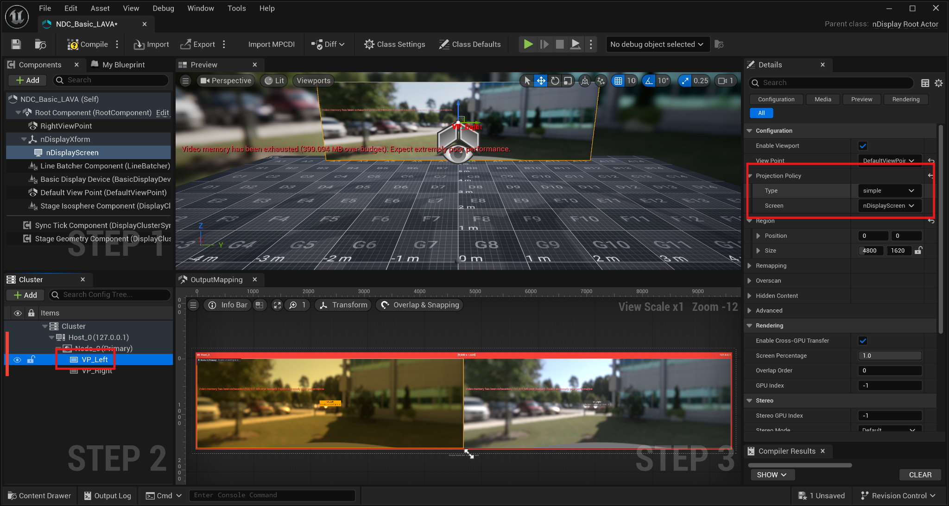
- Similarly, for VP_Right set the Configuration/View Point to RightViewPoint and set the Projection policy to Simple, and Projection Policy/Screen to nDisplayScreen.
- After making all the edits, click on Save and Compile in the top left of the editor window. Then close the editor window.

If you’re wondering what the settings for the NDC_Sim_LAVA are, Node_0 is set to 1920x1080, VP_Left and VP_Right are set to half those values, like below:
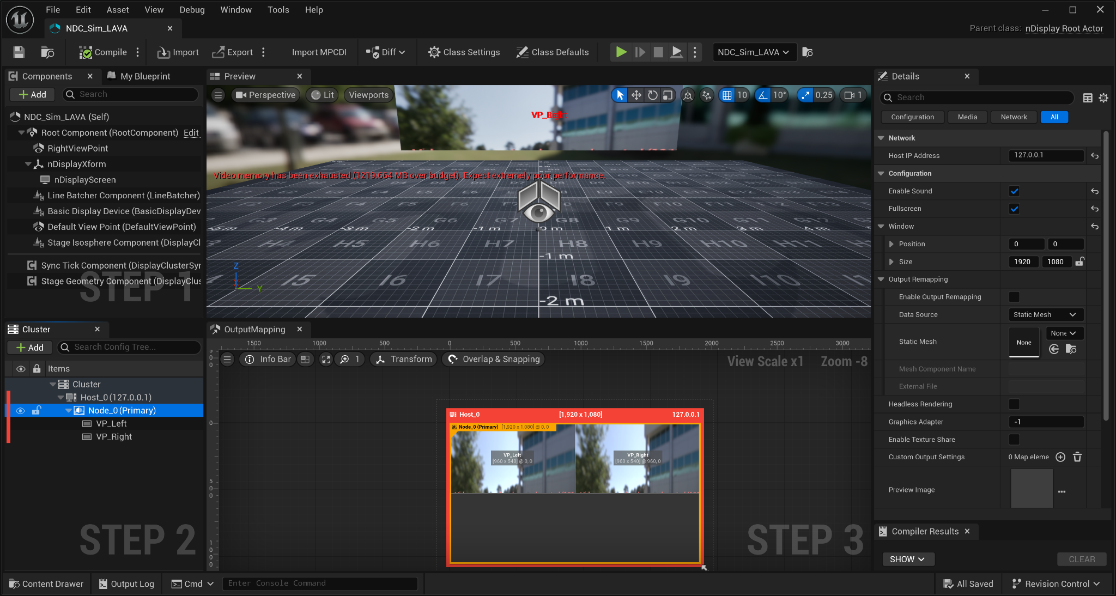

Part F. Tips and Caveats

Running a Packaged App with nDisplay
The above tutorial assumes you will run your nDisplay application from your Unreal editor. However it is possible to build the application to a package and run the executable from Switchboard. All you need to do is to build your game package as you normally would any other game you develop for Unreal, and in Switchboard click on the Settings menu, go to nDisplay Settings and browse and select your executable program.

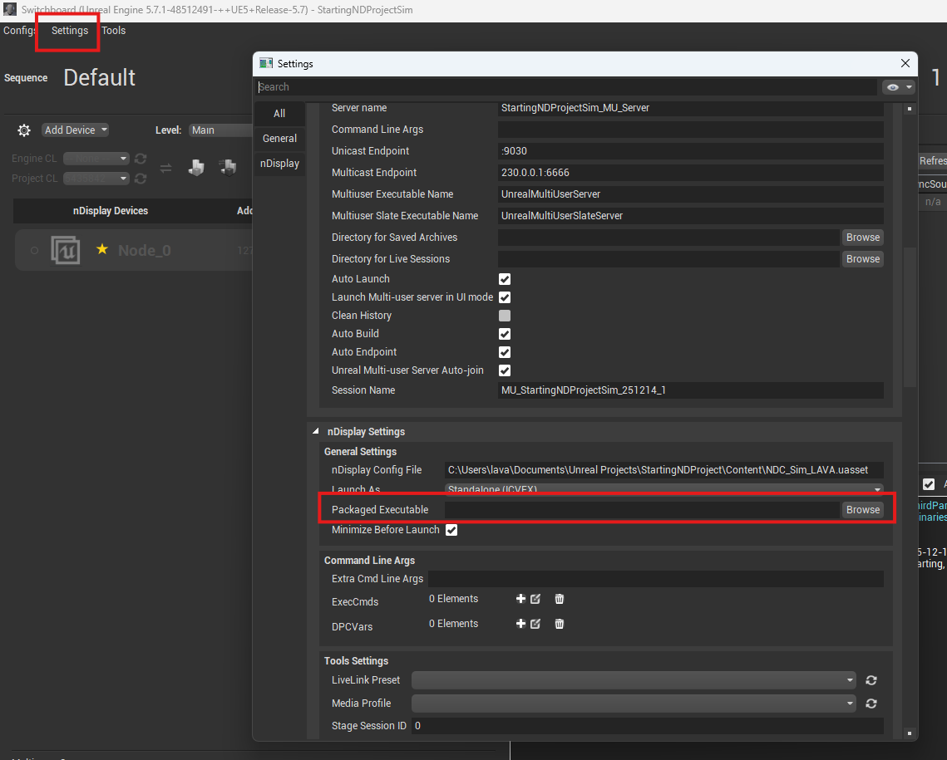

However, letʻs say you are deploying on a new computer and you need to configure everything from scratch. Here's what you need to do:

- Inside the folder with your packaged app, place a copy of the .uasset files for all the display configurations you wish to support (i.e. NDC_Basic_LAVA.uasset, NDC_Sim_LAVA.uasset, and NDC_Basic_SamAcer.uasset).
- Copy the entire folder containing your packaged app to the new computer.
- On the new computer (assuming you have installed Unreal already), start the Switchboard Listener and the Switchboard.
- In the Switchboard, create new configurations for each of the display configurations you intend to support.
- When creating a new configuration, set uProject and Engine Dir to blank.
- Add a new device and select nDisplay.
- Set config to point to the nDisplay asset in your packaged app folder.
- Set Launch As to Packaged Game
- Set Packaged Executeable to point to the .exe file of your packaged app.
- Then run your packaged app like you did before with nDisplay as in Part 14 d and e.

Note: from then onwards, if you wish to launch your Unreal app you have several options. You can either just run the .exe file by double clicking on it. This will not use any of the nDisplay features. Or to use one of your nDisplay configurations, launch the Switchboard Listener and Switchboard and run the app from the nDisplay configuration.

Lastly, there is a way to run all this in a batch script so you donʻt have to go through these steps. But thatʻs for another time.

